Anna Sours

01 Excel Homework

**1. Given the provided data, what are three conclusions we can draw about Kickstarter campaigns?**

According to category statistics analysis, for the years studied theater campaigns are the most popular category (Figure 1). Overall, the campaigns with greatest overall numbers are theater, music, technology, and film & video.

(double check this).

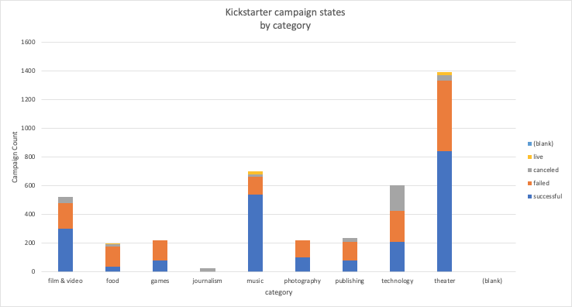

Kickstarter campaigns are most popular in the US compared with other countries. The US has a huge amount of kickstarter campaigns compared with any other country. The majority of campaigns launched are in the US (3038 to 1076 in all other countries combined).

Overall, there appear to be more successful campaigns than those that are failed, live, or canceled at any given time of year. Total numbers of campaigns are greatest in the summer months (May, June, July) with less campaigns in September and December. There appear to be slightly more failed campaigns than successful in December. Campaigns are more likely to reach funding goals in the summer months rather than any other time of year.

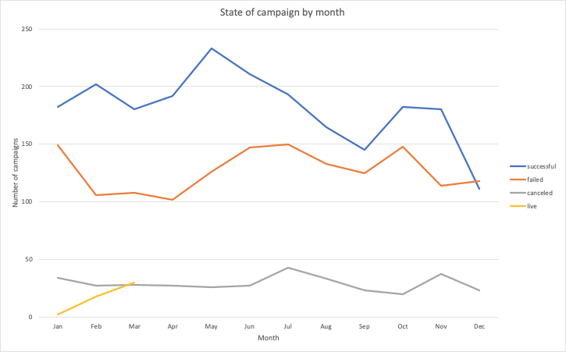

**2. What are some limitations of this dataset?**

The data is easily misleading in comparing campaign states - there are many categories and subcategories without data on one or more of the states (canceled/failed/live/successful), so analysis based on comparison between campaign states must take this into account. Are these data unreported or do they not exist (and what conclusions can be drawn as a result)?

Because of the high number of observations for campaigns located in the US as compared to any other country, the data is skewed towards a US market. It would be less biased if we were able to include more campaigns from countries outside of the US as well, and perhaps shift the outcomes.

Some of the data are non-numeric and not defined, so clarification is needed to better analyze. For example, staff pick and spotlight are non numeric and specific to Kickstarter. They are challenging to analyze out of context.

**3. What are some other possible tables and/or graphs that we could create?**

Using the data provided, we could analyze average donation by country, category, and subcategory in order to learn more about donation size in kickstarter campaigns.

Looking only at successful campaigns, It would also be interesting to compare launch and end date for campaigns to analyze how long each took to be funded, as well as how much above their goal did they earn, then filter by subcategory and category.

Two observations that were not yet touched that were provided in the data set are spotlight and staff picks. According to the Kickstarter website, these are designations assigned to certain campaigns based on staff preference and additional factors. It would be interesting to analyze how either of these designations affects state of campaign, amount pledged, number of backers, and average donation.